Ink Inventory Web Application

**Overview**

What follows is a brief presentation of a web application created to address problems of maintaining our ink inventory as well as suggestions for an alternative look moving forward with our department.

**Current Situation**

Right now our current method of maintaining our ink and printer inventory is by having our employees manually edit a shared Excel sheet on the apsfs drive. There are pros and cons which I will write out in the following section:

Advantages:

* Put together by Chris and I, it contains all the printers maintained by our IT department as well as their location and their corresponding toners. This includes locations such as our headquarters, Livingston, Douglass and Busch.
* Contains and audit page where our employees are supposed to input the ticket number and the toner they removed as well as the date so Todd can bill the appropriate departments.
* One shared excel file that is accessible by everyone

Disadvantages:

* The excel sheet requires constant maintenance which can lead to errors when updating the file as well as weekly inventory checks to ensure it is up to date.
* It doesn’t notify Todd or Joe when we are low or out of toner. This is detrimental to the departments that need ink right away, especially when the file is not routinely updated.
* The file is easily accessible so changes can be made by anyone without knowledge of who made the change. This means if someone updates the inventory but not the audit, Todd is left with back tracking which department received toner or worse, when the file isn’t updated at all.
* The file cannot be edited while opened by another user. So in an instance where someone has the file open and leaves for the day, we have no idea who has the file open and are unable to update the spreadsheet until it is closed. Causing a deterrent to updating the file.
* File requires multiple instances of input which can cause an employee to forget to edit the audit or total inventory page

After reading through Chris’s Bi-annual report on our toner usage, we talked about a better way to manage our ink to minimize these problems in the future. We decided it was best to go for a webpage that can be hosted for on our domain and only accessible to the IT department. So, I’ve created an easy to use webpage and an accompanying database that will allow our department better control over our inventory.

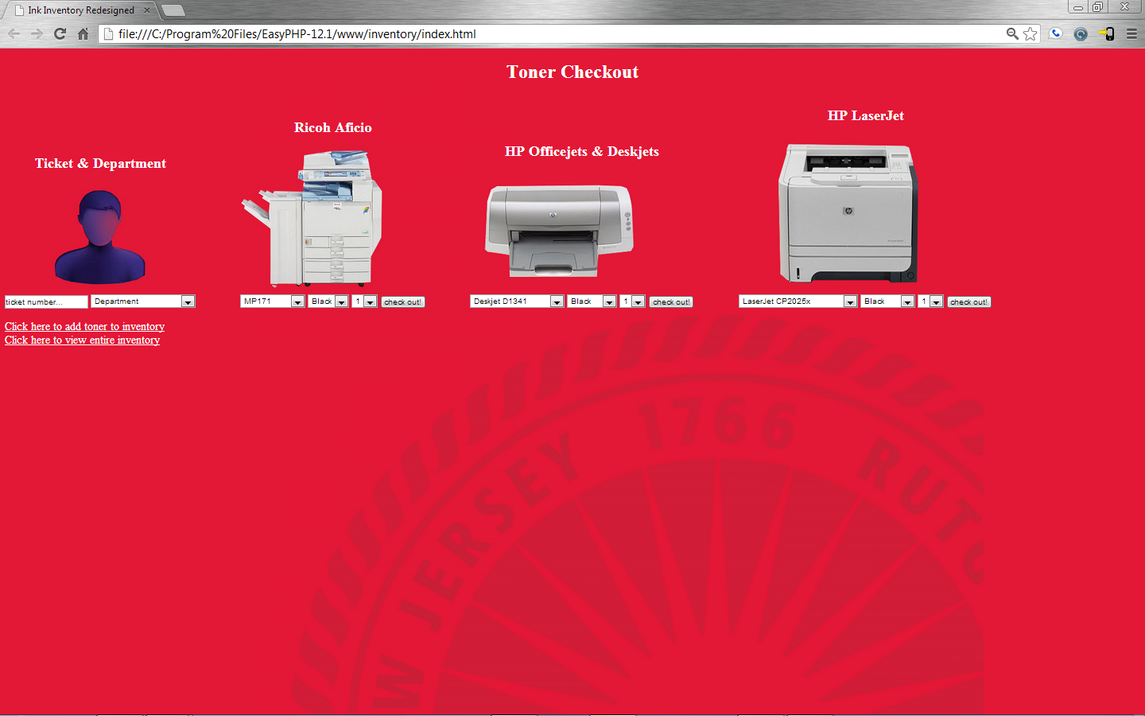**Proposed Ink Inventory Application**

How to use:

1. To update the inventory, our employees will be required to enter the ticket number that prompted the toner request, followed by the department it is for. If these fields are not enterd, they will not be able to proceed to check out toner.
2. The first drop down box for each printer type contains all the printers we currently have for that model.
3. The second is a selection of colors that are available for the selected printer.
4. Lastly the amount you want to remove from the inventory.
5. Before the check out is made, you are prompted to confirm that you are removing the right toner. If so an email is sent to Todd with the ticket number, department, which toner and how many were removed. A log is recorded for further viewing and analysis and the inventory is updated. If you realize that you made a mistake in your selection the undo button allows you to start over.

There are 2 links on the page that allow you to add toner to the inventory when we receive new shipment and an option to view the entire inventory.

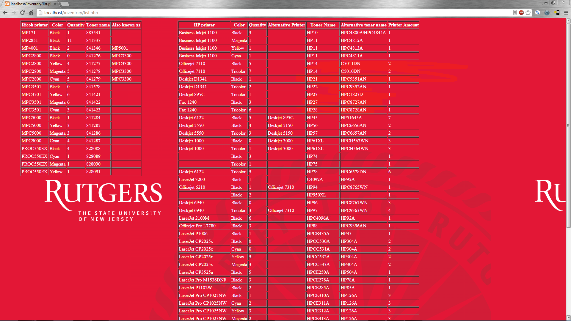

Advantages:

* Contains all the information our current excel sheet holds.
* Centralized database that isn’t limited to being opened one person at a time. As well as being easily managed to add more information if needed via future updates.
* Easily formatted inventory view for employees and managers to see our printers, stock of toners, amount of printers and toner names.
* Easily accessible via web link and limited amount of user input, meaning less user error while maintaining precision.
* Notifications to Todd and/or Joe when inventory is low or empty. During field testing, we can adjust the frequency and minimum level amount for the notifications to be sent.
* Keeps track of the ticket number, department, toner and date the toner was removed.

Disadvantages:

* Requires space on one of the servers running apache and MySQL to be made live. The current size of the database and website is close to 1 MB.

**Current Status**

Currently the webpage is complete and needs field testing to stomp out any bugs or inconsistent data that it may have. All tests that I have performed have been successful. There are several things that I would need to get this up and running for the IT department, the first being granted access to allow this code to be put on one of the servers running apache and MySQL. The second is field testing by our department to receive input on needed features and missing information. Third would be continuous access to the web sites source code to make necessary changes or this can be handled by Sue Brown.

**Future Implementation**

If this system is implemented, this opens the door for other possibilities that may be available to our IT department in terms of inventory. Right now KACE/Kaspersky and our excel sheet are the best inventory system we have right now. If we continue to build off this web page, we can expand its functionality to include:

* Analysis of toner usage to create reports on most used toners, referrals and orders.
* Suggestive purging of low use printers to decrease cost of expensive but hardly used toners and to increase efficiency in toner usage and ordering.
* We can begin to inventory our keyboard, speakers, mice, monitors, projectors, laptops, spare and new pc’s.
* Establish a link with TechExcel to ensure precision with our inventory
* Barcode scanning features to be implemented with new inventory so they are automatically handled by the system
* Being able to precisely pinpoint IT equipment
* Any suggestions that can benefit the department in which our current system doesn’t allow will be available.

**Final thoughts**

Chris and I envisioned a better inventory system for BAS, one that is simple but powerful. We hope to make the department better by being more efficient in areas where it counts allowing us more time to take care of our responsibilities and to attend to our customers. I hope that this can be another step to continue the drive towards a better and more productive future for our IT department.